GaDOE Pupil Transportation

Model Training Units

User Guide

October 23, 2007

Refer to Superintendents Report Log-in Procedures (pp 3-8) - AFTER SUCESSFULLY ENTERING THE PORTAL

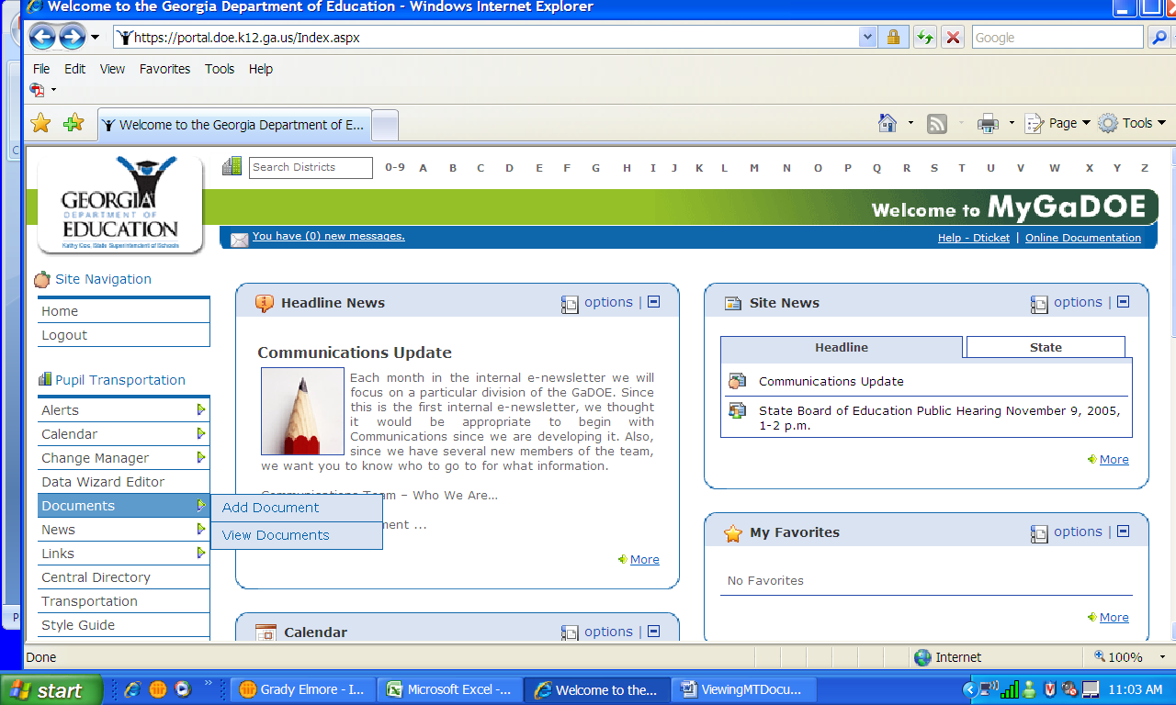
On the left side of the page, Click “Documents”, then click View Documents.
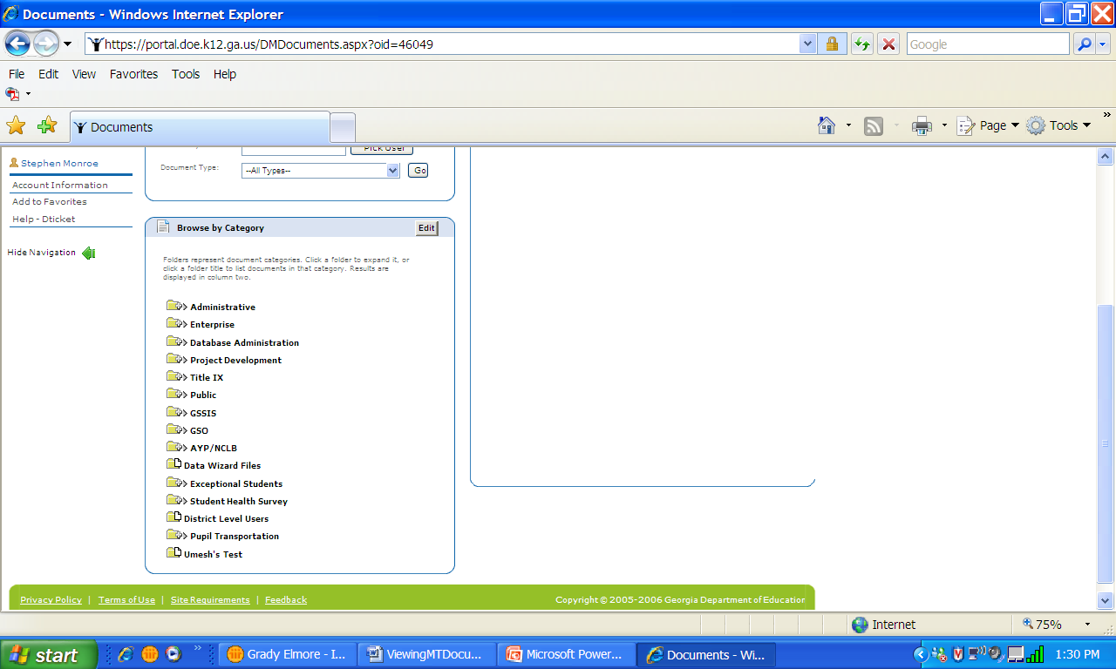
Once you click view documents, scroll down to the bottom of the page on the left hand side and click on the FOLDER Pupil Transportation, not the actual name Pupil Transportation.
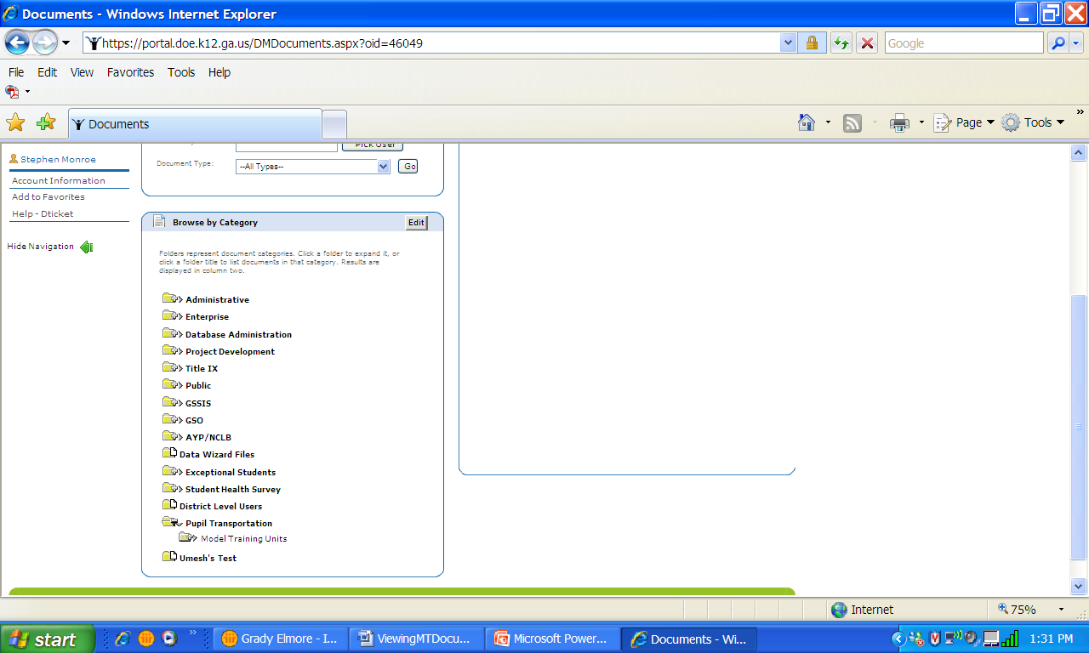
After you click on the Pupil Transportation folder, a set of sub-folders will appear. Click on the FOLDER Model Training Units, not the actual name Model Training Units.
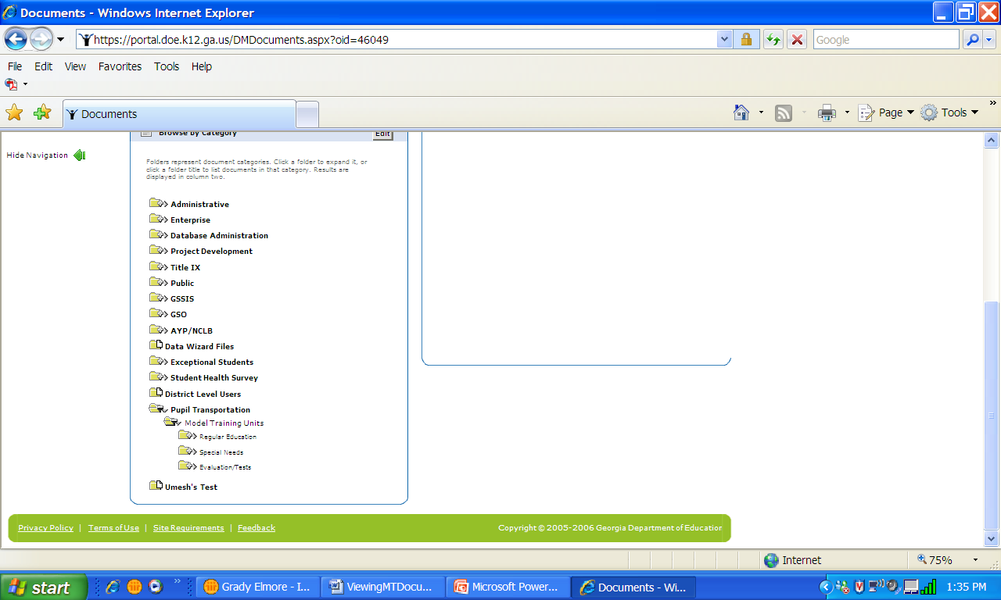
Once the sub-folders appear, click on one of the three FOLDERS available – Regular, Special Needs, Evaluation-Tests -, not the actual name.
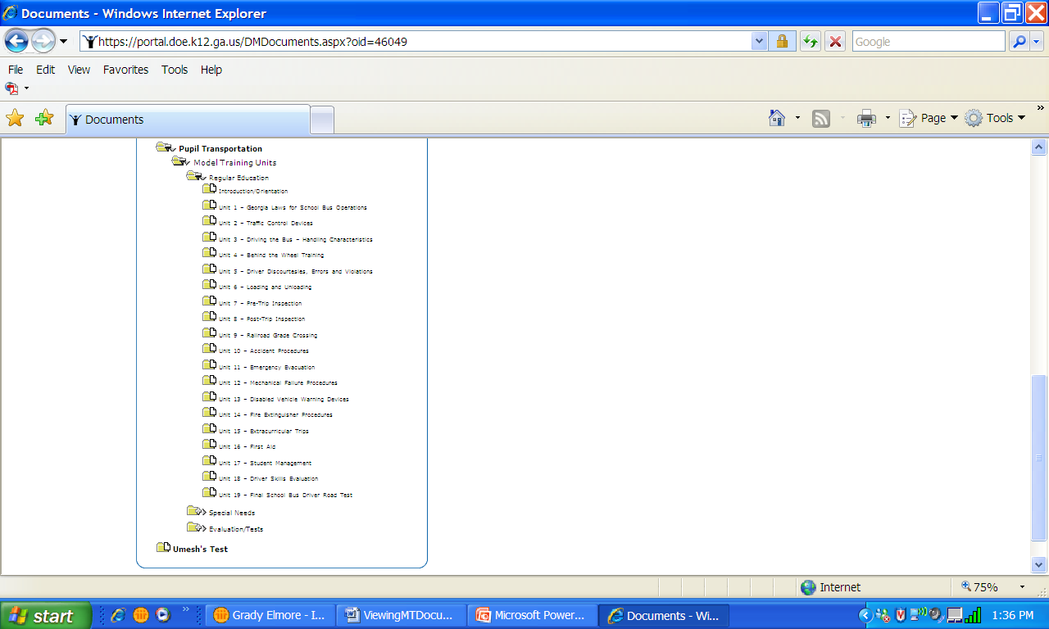
Click on the FOLDER of the Training Unit you wish to open.
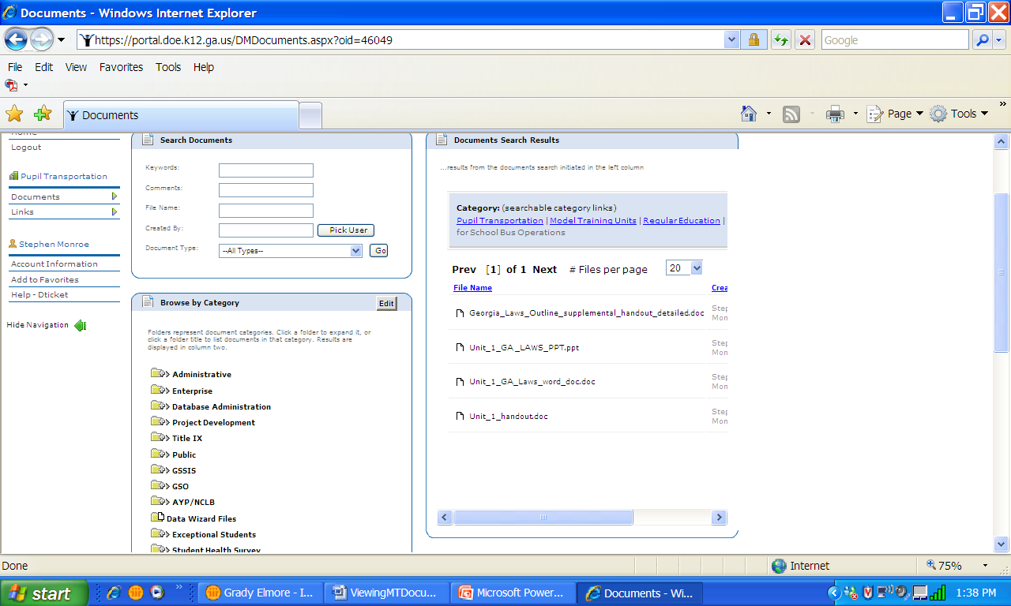
On the top right side of the screen , all the documents for that particular Unit will be displayed.

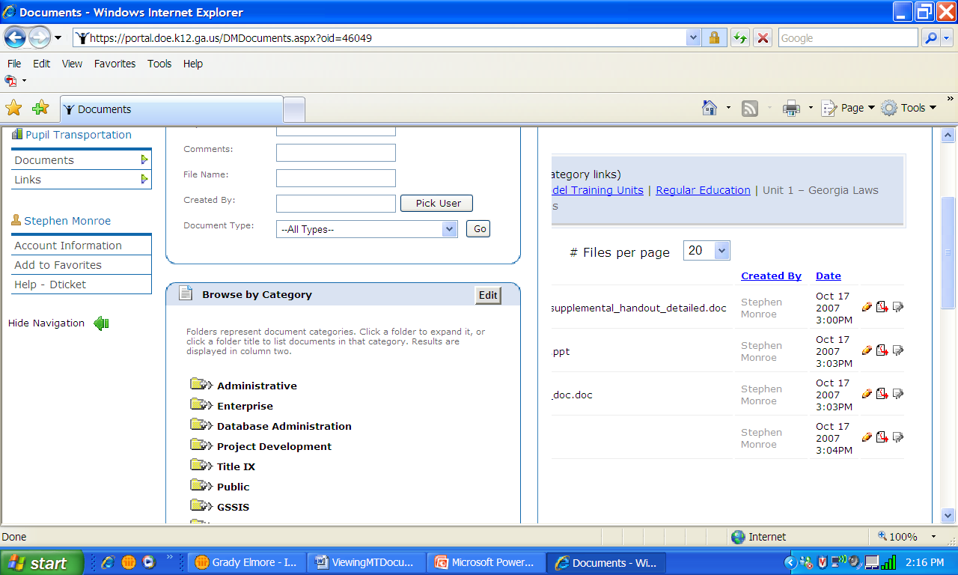
Click on the Middle Icon to the right side of the screen, not either of the two on each side.
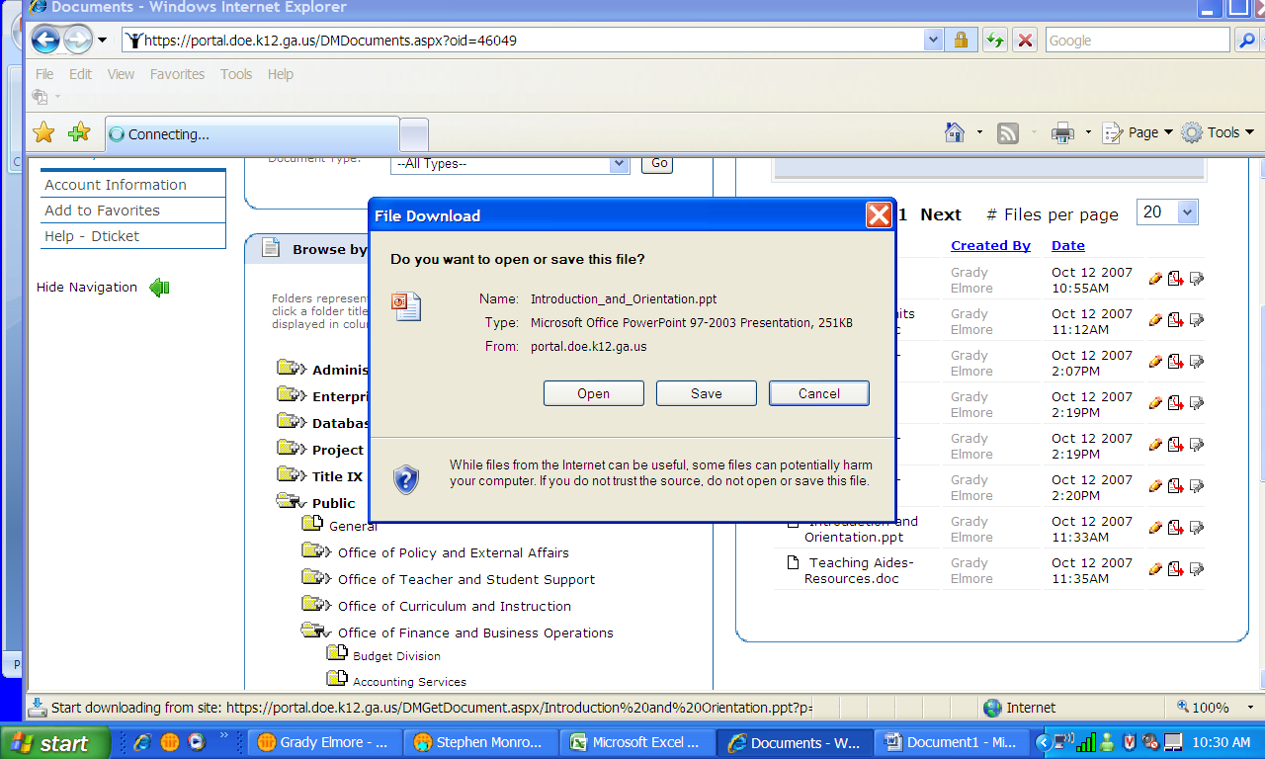
You will be given a screen that allows you to open the document or save it to a folder on your computer. **I recommend that you create a Model Training Folder in you ‘My Documents” folder before downloading any units from the portal, then create 31 individual unit folders inside there and title them per the manual. This will allow you to place the documents directly into your folders directly by unit. You will download the documents one at a time.
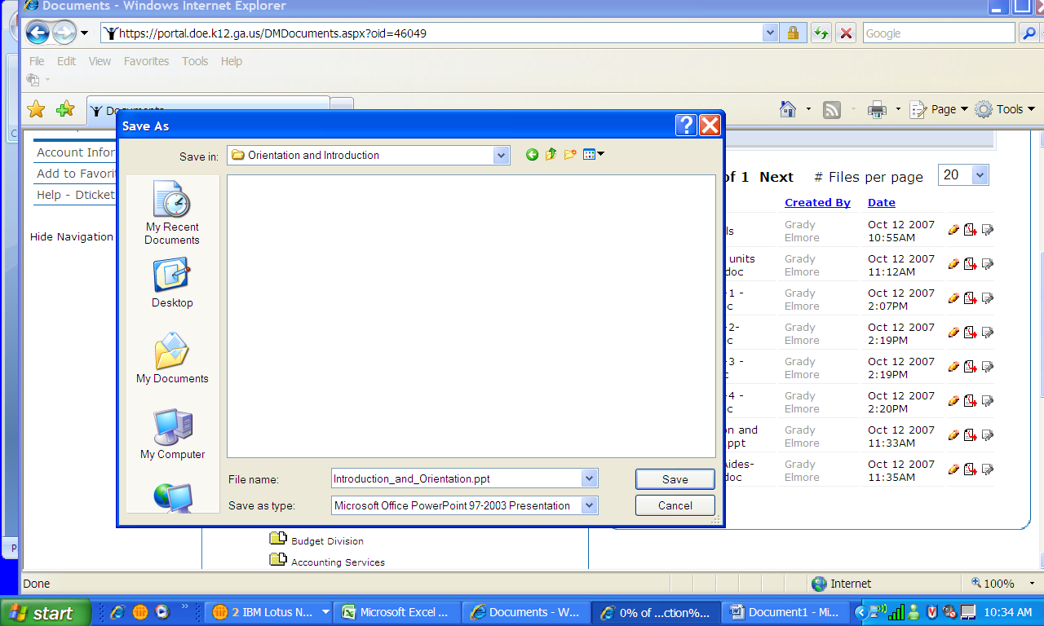
If you clicked the ‘save’ button, this screen will appear. You will select the folder in which you want to view. At this time you can also save the document saved to your folders. (By having the folders already created, you would just save to those folders).
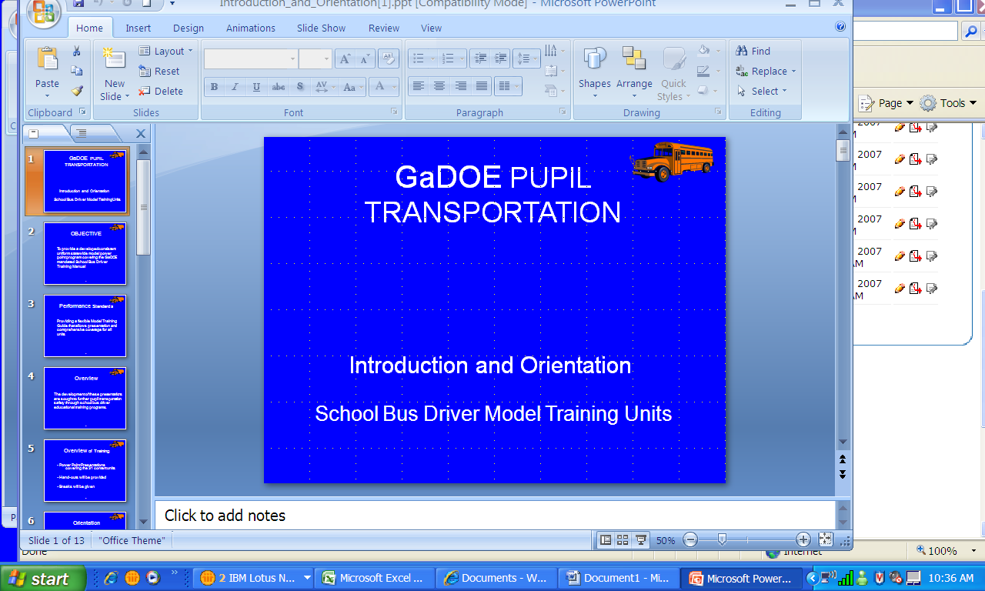
If you select to ‘open’ the document, the document will display on the screen. You can view this, show this, or save it to a folder on your computer.
IN A NUTSHELL:
- Open Portal
- Go to Documents on left side of page
- Click View documents
- Click on FOLDER Pupil Transportation at bottom at page
- Click on Model Training Units FOLDER
- Select which folder – Regular, Special Needs, Evaluation/Tests
- Select Unit FOLDER
- Save or Open – I suggest you create your folders on your computer in advance to make saving easier.

