Georgia Department of Education
Pupil Transportation
Bus Inventory Guide

Copyright

Copyright © 2011 GA Department of Education.
All rights reserved

These materials are confidential and proprietary. Due to continued product development this information may change without notice. The information and intellectual property contained herein is confidential between GA Department of Education and the client and remains the exclusive property of GA Department of Education. If you find any problems in the documentation, please report them to us in writing. GA Department of Education does not warrant that this document is error-free.

GA Department of Education
Twin Towers
205 Jesse Hill Jr. Drive SE
Atlanta, Georgia 30334
Website: http://www.doe.k12.ga.us
Table of Contents

Logging in to Pupil Transportation 1
Creating Bus Records Using the Bus Inventory form 3
Editing Bus Records Using the Bus Inventory form 7
Deleting Bus Records Using the Bus Inventory form 9

Logging in to Pupil Transportation
These procedures list the steps to access Pupil Transportation.
- Browse to the GaDOE website: http://public.doe.k12.ga.us/.
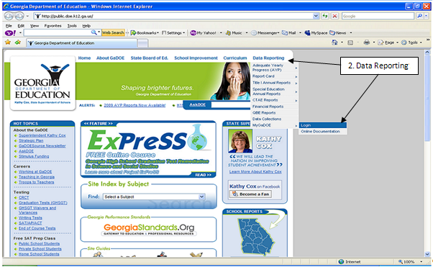
- Browse to the Data Reporting tab on the upper right-hand of the page and select “MyGaDOE Login”.
The Log In form is displayed.
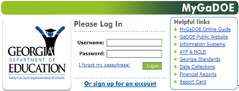
- Enter your email address into the Username field.
- Enter your Password.
- Select the Login button.
The MyGaDOE Home Page is displayed.
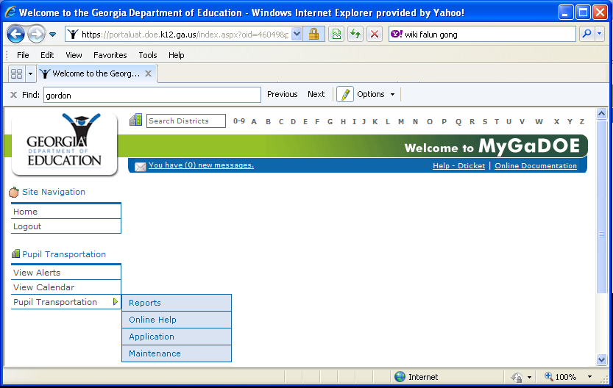
REMINDER: GaDOE Portal security is designed to time-out within approximately 20 minutes of inactivity (Inactivity is when the selection of the Save button is not performed).
Save often to assure that data entered is stored in the Pupil Transportation application.

Creating Bus Records Using the Bus Inventory form
Who uses this procedure? Pupil Transportation Directors
This procedure lists the steps to create a bus record using the Bus Inventory page.
REMINDER: GaDOE Portal security is designed to time-out within approximately 20 minutes of inactivity (Inactivity is when the selection of the Save button is not performed). Save often to assure that data entered is stored in the Pupil Transportation application.
Note: The Print option is available at all times. Also, the Audit Trail tab displays transaction information.
- Log into MyGaDOE. See Login to Pupil Transportation for instructions (see page 1).
- Select Maintenance from the Pupil Transportation main menu.
The Maintenance page is displayed.
- Select Bus Inventory from the Select Maintenance Form field.
The Bus Inventory form is displayed.
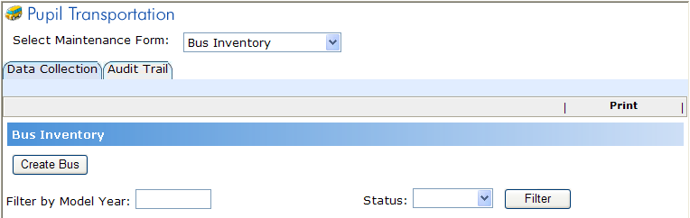
- Select the Create Bus button.
The form expands.
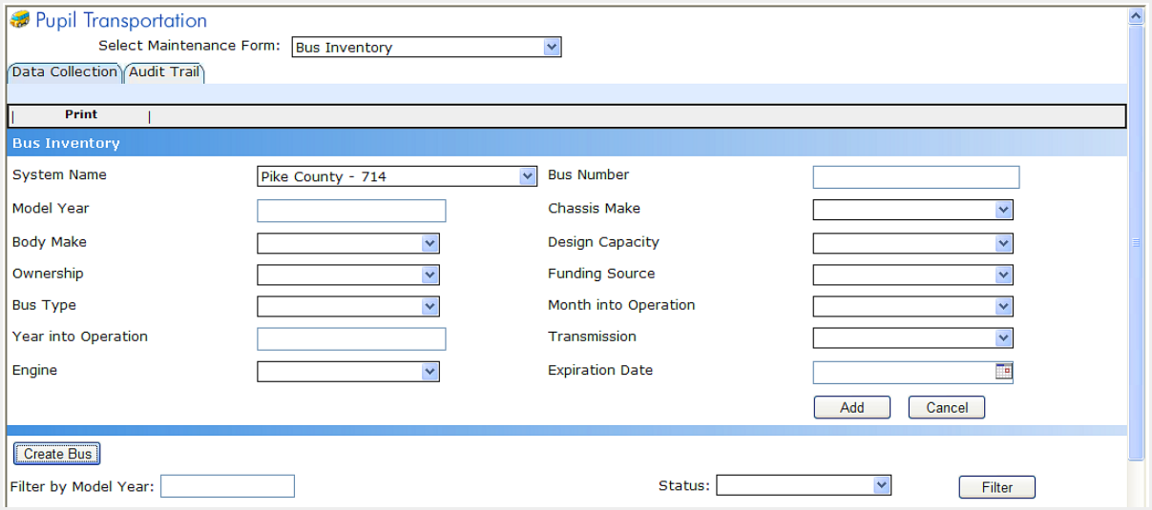

- Select the System Name.
Note: This field is limited by the system(s) to which the user is assigned.
- Enter a Bus Number.
- Enter a valid Model Year (e.g., 1990, 2001).
Note: This must be 1978 or later.
- Select a Chassis Make.
- AMT (Am Tran)
- B-B (Bluebird)
- CHEV (Chevrolet)
- FORD (Ford)
- FRT (Freightliner/Thomas)
- GMC (GMC)
- INT (International/Navistar)
- Select a Body Make.
    - B-B (Bluebird)
    - CAR (Carpenter)
    - COL (Collins)
    - INT (International)
    - SUP (Superior)
    - THO (Thomas)
    - WAD (Ward/AmTran)
    - WAY (Wayne)
    - OTH (Other as a catch-all)
- Select a Design Capacity (the maximum number of passengers the bus body was designed to transport with all school bus seats installed).
- Select an Ownership type.
  - C: The system making the report owns the bus.
  - P: The system making the report CONTRACTS for the use of the bus with a private individual, private organization, another public school system, or any other organization.
- Select a Funding Source.
  - Local: The bus was purchased with local and/or “replacement” funds.
  - Bond: The bus was purchased with Bond funds.
- Select a Bus Type.
- A: Bus is a conversion or body constructed upon a van-type or cutaway front-section vehicle with a left side driver’s door, designed for carrying more than 10 persons. This definition shall include two classifications: Type A-1, with a Gross Vehicle Weight Rating (GVWR) less than 14,500 pounds; and Type A-2 with a GVWR greater than 14,500 pounds and less than 21,500 pounds. Sixteen passenger or less may be single rear wheeled; 17 passenger and larger shall have dual rear wheels.
- B: Bus is constructed utilizing a body on a stripped chassis, with the entrance door behind the front wheels. This definition includes two classifications: Type B-1, with a GVWR of 10,000 pounds or less, designed for carrying more than 10 persons and Type B-2, with a GVWR greater than 10,000 pounds. The engine is beneath and/or behind the windshield and beside the driver’s seat. Both Type B-1 and Type B-2 must be equipped with dual rear tires.
- C: Bus is a body installed upon a flat-back cowl chassis with a hood and fenders, with a GVWR of more than 21,500 pounds, designed for carrying more than 30 persons. This type also includes the cutaway truck chassis or truck chassis with cab, with or without a left side door. The entire engine is in front of the windshield and the entrance door is behind the front wheels.
- D: “Transit Style” school bus is a body installed upon a stripped chassis, with the engine mounted in the front or rear, and has a GVWR of more than 21,500 pounds, designed for carrying more than 10 persons. The engine may be beside the driver’s seat or it may be at the rear of the bus, behind the rear wheels. The entrance door is ahead of the front wheels.
- Select a Month into Operation.
- Enter a valid Year into Operation (e.g., 1990, 2001).
Note: Year into Operation cannot be prior to, nor more than two years later than the Model Year.
- Select a Transmission type.
- 1 – Indicates a standard gear shift
- 2 – Indicates an automatic gear shift
- Select an Engine type.
- 1 – Indicates Gasoline
- 2 – Indicates Diesel
- 3 – Indicates Butane or Propane
- 4 – Indicates Natural Gas
- (Optional) Enter an Expiration Date.
Note: This field cannot be less than the current calendar date. Only bus records that do not have an Expiration Date entered or the entered Expiration Date is after the current calendar date, will appear in other Pupil Transportation forms.
- Select the Add button.
The Pupil Transportation application creates a bus record and lists the record in the table below the form (see below).
- To view the records
  - (Optional) Enter a valid year in the Filter by Model Year field. This will filter the list of bus records.
  - Select a Status. This is the Expiration Date status.
- All = All records (Active and Inactive)
- Active = All records that have an Expiration Date after the current calendar date.
- Inactive = All records that have an Expiration Date equal to or prior to the current calendar date.
  - Select the Filter button.
Note: There can be multiple bus records per system.
For example.
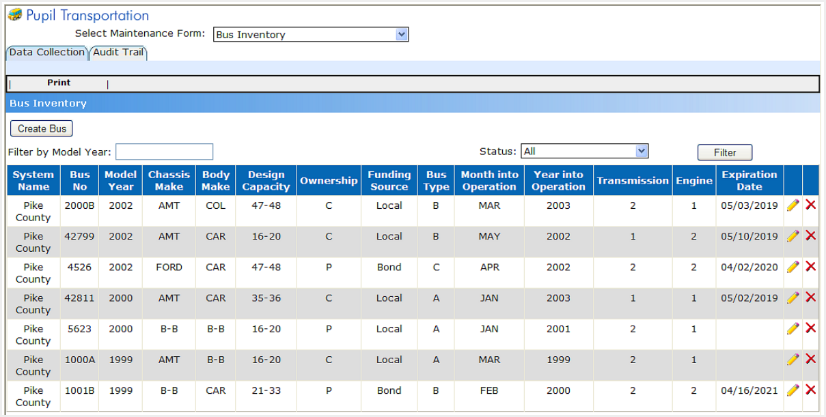

Editing Bus Records Using the Bus Inventory form
Who uses this procedure? Pupil Transportation Directors
Prerequisite: Creating Bus Records using the Bus Inventory form (see page 3)
This procedure lists the steps to edit a bus record in the Bus Inventory form.
REMINDER: GaDOE Portal security is designed to time-out within approximately 20 minutes of inactivity (Inactivity is when the selection of the Save button is not performed). Save often to assure that data entered is stored in the Pupil Transportation application.
Note: The Print option is available at all times. Also, the Audit Trail tab displays transaction information.
- Log into MyGaDOE. See Login to Pupil Transportation for instructions (see page 1).
- Select Maintenance from the Pupil Transportation main menu.
The Maintenance page is displayed.
- Select Bus Inventory from the Select Maintenance Form field.
The Bus Inventory form is displayed.
- Search for bus record(s):
  - Select Create Bus to display the bus record creation fields.
  - Select a System. This will filter the list of bus records.
  - (Optional) Enter a valid year in the Filter by Model Year field. This will filter the list of bus records.
  - Select a Status. This is the Expiration Date status.
- All = All records (Active and Inactive)
- Active = All records that have an Expiration Date after the current calendar date.
- Inactive = All records that have an Expiration Date equal to or prior to the current calendar date.
  - Select the Filter button.
A table is displayed below the form displaying bus records for the selected system, model year, and status. For example:
- Scroll right and select the edit button for the record to be edited.
The form above the table displays that bus record. For example.
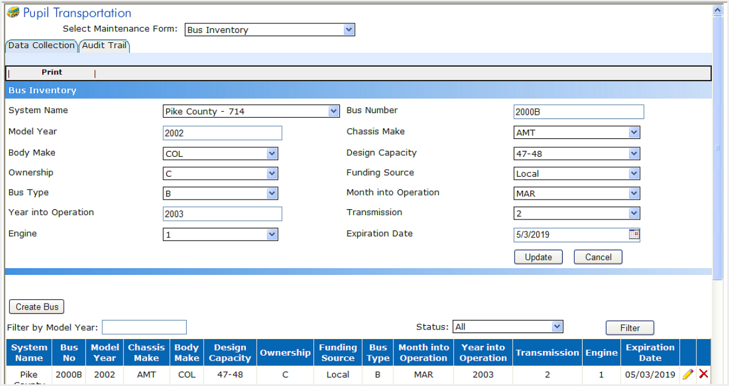
- Edit the record.
Note: Refer to Creating Bus Records using the Bus Inventory form for field descriptions (see page 3).
- Select the Update button.
The bus record is updated in the bus record table.

Deleting Bus Records Using the Bus Inventory form
Who uses this procedure? Pupil Transportation Directors
Prerequisite: Creating Bus Records using the Bus Inventory form (see page 3)
This procedure lists the steps to delete a bus record in the Bus Inventory form.
Note: The Print option is available at all times. Also, the Audit Trail tab displays transaction information.
- Log into MyGaDOE. See Login to Pupil Transportation for instructions (see page 1).
- Select Maintenance from the Pupil Transportation main menu.
The Maintenance page is displayed.
- Select Bus Inventory from the Select Maintenance Form field.
The Bus Inventory form is displayed.

- Search for bus record(s):
  - Select Create Bus to display the bus record creation fields.
  - Select a System. This will filter the list of bus records.
  - (Optional) Enter a year in the Filter by Model Year field. Enter all four numbers. This will filter the list of bus records.
  - Select a Status. This is the Expiration Date status.
- All = All records (Active and Inactive)
- Active = All records that have an Expiration Date after the current calendar date.
- Inactive = All records that have an Expiration Date equal to or prior to the current calendar date.
  - Select the Filter button.
A table displays below the form displaying bus records for the selected system, model year, and status. For example:
- Scroll right and select the delete button for the record to be deleted. A confirmation window is displayed.
Note: A record cannot be deleted if there is Pupil Transportation application historical data associated to the Bus Inventory record.
- Select OK to confirm the deletion.
The bus record is deleted.

