Leadership Team
Meeting Agenda
April 1, 2019

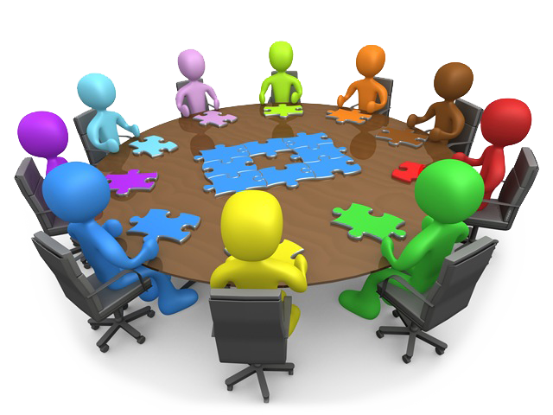
Organize productive, effective leadership team meetings that build collective leadership capacity to continuously improve outcomes for students
This Photo by Unknown Author is licensed under CC BY-SA-NC
Date: ______________
Time: ______________
Location: ___________

ATTENDANCE
☐ LT Member Name, Position | ☐ LT Member Name, Position | ☐ LT Member Name, Position
☐ LT Member Name, Position | ☐ LT Member Name, Position | ☐ LT Member Name, Position
☐ LT Member Name, Position | ☐ LT Member Name, Position | ☐ LT Member Name, Position
☐ LT Member Name, Position | ☐ LT Member Name, Position | ☐ LT Member Name, Position
☐ LT Member Name, Position | ☐ LT Member Name, Position | ☐ LT Member Name, Position

MEETING OBJECTIVES
Participants will…
• Reflect on their leadership work and plan for continuous improvement.
• Apply questioning, facilitation, and decision-making strategies that facilitate adult learning and structure meaningful conversations that drive improvements in teaching and learning.
• Review the School Improvement Plan (SIP) to assess implementation progress and impact on student learning.

SCHOOL VISION and MISSION
VISION:

MISSION:

Enter the school improvement goals from the SIP. Record action steps due within 30-45 days of the date of the leadership team meeting, include any incomplete past due action steps.
SCHOOL IMPROVEMENT PLAN GOALS AND CURRENT ACTION STEPS
SIP Goals | Action Steps | System/ Structure | Position Responsible | Due Date
SIP Goal #1:
SIP Goal #2:
SIP Goal #3:

AGENDA
Action Item | Discussion Leader, Time Allotment, and Purpose | Preparation, Resources, and Protocols | Minutes
Leadership Team Norms:  - Start and end on time  - Respect differing views  - Remain engaged  - Support final decisions | DL:  Time:  Purpose:  ☒ Information  ☐ Input  ☐ Decision | Team Roles:  Facilitator:  Minute Recorder:  Time Keeper:
What changes, if any, should we make to the agenda? | DL:  Time:  Purpose:  ☐ Information  ☒ Input  ☐ Decision | Read agenda and come prepared with suggested changes.
What deltas from the previous meeting will we focus on during the current meet? | DL:  Time:  Purpose:  ☐ Information  ☐ Input  ☒ Decision | Review previous meeting deltas:  ☐ (Delta 1)  ☐ (Delta 2)  ☐ (Delta 3)
What recent events or successes can we celebrate? | DL:  Time:  Purpose:  ☒ Information  ☐ Input  ☐ Decision
What is the status of each action steps for SIP goal #1? | DL:  Time:  Purpose:  ☐ Information  ☐ Input  ☐ Decision | - Review action steps for goal #1 above.  - Responsible position will prepare update.
What is the status of each action steps for SIP goal #2? | DL:  Time:  Purpose:  ☐ Information  ☐ Input  ☐ Decision | - Review action steps for goal #2 above.  - Responsible position will prepare update.
What is the status of each action steps for SIP goal #3? | DL:  Time:  Purpose:  ☐ Information  ☐ Input  ☐ Decision | - Review action steps for goal #3 above.  - Responsible position will prepare update.
What does the analysis of our data review show? What are the next steps? | DL:  Time:  Purpose:  ☐ Information  ☐ Input  ☐ Decision | Data Source:  Data Analysis Protocol:

Action Item | Discussion Leader, Time Allotment, and Purpose | Preparation, Resources, and Protocols | Minutes
What operational matters need to be discussed? How will operational items affect instruction? | DL:  Time:  Purpose:  ☐ Information  ☐ Input  ☐ Decision
What do we see as the next steps? Who should take responsibility for them? And what should the timeframe be? | DL:  Time:  Purpose:  ☐ Information  ☐ Input  ☐ Decision | - Review meeting discussions/decisions  - Seek team input  - Complete “Next Steps” chart on page 2.
What did we do well this meeting, and what should we change for the next meeting? (Plus/Delta)  - Was the agenda distributed in time for everyone to prepare?  - How well did team members prepare for the meeting?  - How well did we estimate the time needed for each agenda item?  - How well did we allocate our time for decision making and discussion?  - How well did everyone stay on-topic? How well did team members speak up when they thought someone was off-topic?  - How effective was the process for each agenda item? | DL:  Time:  Purpose:  ☐ Information  ☒ Input  ☐ Decision | - Review guiding questions  - Review meeting discussions/decisions  - Complete one Plus and one Delta suggestion on sticky note  - Post on Plus/Delta chart upon meeting adjournment  - Minute Recorder will enter plus/deltas into minutes  Note: Deltas are suggestions for improvements, not complaints. | Plus +:  Delta :

Next Steps | Person(s) Responsible | Due Date
Dates/Reminders

• Create a clearly written agenda for every meeting to ensure the team remains on task and on schedule throughout the meeting.

• Agendas should be distributed at least 24 hours prior to meetings to help ensure team members come to each meeting prepared.

• Facilitators are generally responsible for preparing the agenda, so they will need to gather general input from members prior to creating the agenda. Information can be gathered through informal conversations, emails, anonymous drop box. Always request a due date for input.

• Only put items on the agenda that need to be addressed in a face-to-face format.

• Ensure that each agenda item has sufficient time for meaningful discussion and problem solving.

• Agendas ideally focus on similarly related items connected to the meeting’s purpose. Too many different topics prevent a team from going in-depth on the topic and causes confusions about purpose of the meeting.

• Agenda topic(s) should be broken down into manageable sections for discussion and actions.

• Strategically order the agenda topics to ensure the meeting runs smoothly.

• Place agenda items that need creative or energetic thought near the beginning of the agenda, if appropriate. Place ‘hot’ topic items strategically on the agenda.

• Use a verb associated with each agenda item to help the team understand the purpose for the agenda item (i.e.: make a final decision on…; review and discuss….; brainstorm….; develop…)

• Include an outcome expectation associated with each agenda item.

• Use a ‘parking lot poster’ to facilitate with questions or topics that might lead dialogue away from the purpose of the meeting and off the agenda.

Resources: Leadership Lesson: Tools for Effective Team Meetings - How I Learned to Stop Worrying and Love my Team - By Yvette Pigeon, Ed.D., and Omar Khan, M.D., M.H.

205 Jesse Hill Jr. Drive SE
Atlanta, GA 30334
www.gadoe.org

@georgiadeptofed

Richard Woods, State School Superintendent
Educating Georgia’s Future

