

Request for Proposal

For

The Strengthening Career and Technical Education for the 21st Century Act

PERKINSplus

Reserve Fund Grants

Fiscal Year 2021

Dissemination Date:

January 31, 2020

Deadline:

February 21, 2020

5:00 p.m.

Georgia Department of Education

Division of Career, Technical and Agricultural Education

1752 Twin Towers East

Atlanta, GA 30334

|  |  |  |
| --- | --- | --- |
| **Program Description** | | |
| Name of Grant Program: | | Georgia Career, Technical and Agricultural Education (CTAE) **PERKINS*plus*** *Reserve* Fund Grants |
| Authorization: | | The Strengthening CTE for the 21st Century Act P.L. 115-224 |
| Dissemination Date: | | January 31, 2020 |
| Deadline for Receipt of Applications: | | February 21, 2020 @ 5:00 pm (To allow for adequate implementation time for these grants, the deadline for applications cannot be extended). |
| Purpose: | | To supplement the resources of eligible recipients in rural areas; areas with high percentages of career and technical education students; areas with high numbers of career and technical education students; and areas with disparities or gaps in performance. Section 112 (c)(1)(A)(B)(C)(D) and (2)(A)(B) |
| Options: | | Funds must be spent in accordance with Georgia’s identified options under Section 135 of the Perkins V Act. Please select one of the funding options below and submit the corresponding application for funding. **NOTE: Funding levels subject to availability of federal funds.**  Funding options:     1. Expand or improve LEA’s performance level on any performance indicator except 4S1 ($15,000 maximum).  * Eligible recipients may apply for grant funds to support the implementation of activities to improve its performance on any core indicator, except 4S1. 135 (b)(5)  1. Enhance system/schools efforts to make students aware of, recruit students into and retain students in CTAE nontraditional pathways with under-represented gender enrollment in grades 9-12 ($10,000 maximum). Performance Level 4S1 participation and completion in Georgia’s five identified non-traditional pathways in the following five programs: 135 (b)(5)(M)(S)   **Architecture and Construction; Education & Training; Health Science; Transportation, Distribution & Logistics; and Science, Technology, Engineering, & Mathematics (STEM)**   * Eligible recipients may apply for grant funds to create an awareness, recruit, and retain students in identified nontraditional program(s).  1. Local school systems may apply for grant funds to provide activities to prepare special populations for high skill, high wage, and high demand occupations that will lead to self-sufficiency ($10,000 maximum). 135 (b)(5)(M)(S) 2. Implementing CTAE end-of-pathway assessment (FTE 0-300 ≤ $15,000; FTE 301-1000 ≤ $20,000; FTE 1000+ ≤ $25,000 maximum) 135 (b)(5)(F)   Eligible recipients may apply for grant funds to purchase and administer end-of-pathway assessments for pathway completers. Consultant fees are capped at $30 per hour per person.  **(Continued Next Page)**   1. Eligible recipients may apply for grant funds to enhance efforts to recruit and retain career and technical education program teachers, faculty school leaders, administrators, specialized instructional support personnel, career guidance and academic counselors, and paraprofessionals ($10,000 maximum) 135 (b)(5) (G) 2. Eligible recipients may apply for grant funds to combine two of the above opportunities. The system will be awarded the amount of the highest option selected. 135 (b)(5) |
| Target Populations: | | Target audiences involved in the identified options include career and technology education faculty in partnership with academic faculty members, counselors, and/or administrators involved in CTAE programs. |
| Technical Assistance: | | For technical assistance, please contact:  Ms. Julie Kenny, South Region Coordinator (404) 805-9904  Ms. Sharon Bonner, Central Region Coordinator- (404) 805-9633  Dr. Delmas Watkins, North Region Coordinator - (404) 805-7279 |
| Eligible Applicants: | | Grants are targeted to eligible recipients as defined in Section 131 of the Perkins V Act and include eligible recipients in rural areas; areas with high percentages of career and technology education students; or areas with high numbers of career and technology education students. Final approval for awards will be determined by GaDOE. GaDOE reserves the right to take into consideration geographic distribution, project demonstrated readiness by the eligible recipient, and availability of funds when making decisions. |
| Range of Grant Awards: | | See specific application for award ranges |
| Length of Grants: | | One year |
| Estimated Program Start Date: | | July 1, 2020 (ends June 30, 2021) |
| Fund Use: | | Funds must be spent in accordance with the grant narrative of the five identified priorities.  **Funds may be used for:**   * Consultant services (Consulting fees are limited to $30 per hour). No Personnel Activity Report (PAR) required, and use object code 300. * Substitute teacher fees for the activities funded in the grant application. Use object code 113, and PAR is required. * Faculty honorariums (only allowable for work performed outside the regular workday). Use object code 199, and PAR is required). * Materials and supplies to support curriculum development and professional development * Purchasing of equipment for instruction that supports GADOE approved CTAE Pathways (any equipment purchased with these grant funds must be inventoried and assigned to the respective program)   **Funds may not be used for:**   * Salaries with the exception of honorariums and substitute pay * Tuition * Activities below the fifth grade * Program maintenance at current performance levels * Purchase of career information delivery system site licenses * National, state, or local membership dues or fees * Purchase of curricular materials for new programs beyond a three-year period * Promotional items (e.g. shirts, key chains, bags, mugs) * Construction of temporary or permanent structures * Purchase of equipment for administrative purposes * Purchase of equipment to support infrastructure for distance learning * Individual student dues and fees |
| **Submission Requirements**  **and Information:** | * Each system should submit a completed application as a single file. The filename should follow this format:   FY21 *System Name* PerkinsPlus   * Applications should be submitted through the GaDOE LPlan System at [LPlan@doe.k12.ga.us](mailto:LPlan@doe.k12.ga.us), and send a copy to your CTAE Region Coordinator. **MAKE SURE ALL REQUIRED DOCUMENTS ARE INCLUDED IN ONLY ONE FILE.** * Complete applications must be received by 5:00 pm on February 21, 2020. * If you have not received an email confirmation from LPlan within two working days, please contact your regional coordinator for follow-up. * Forms requiring original signatures must be scanned and included as part of the grant application. * Incomplete applications will not be considered for funding. Please double and triple check the application before submitting. * Applications received after due date and time will not be considered for funding. | |
| **Approved Applications:** | * Approved applications, including all supporting documents and appendices (including your Perkins*plus* award letter), should be uploaded to the “Uploaded Files” tab of the FY21 PerkinsPlus Reserve Grant in the FY21 Consolidated Application by May 15, 2020. | |

**Perkins*plus***

***Expand or improve eligible recipient’s performance on any performance indicator except 4S1.* The proposed budget may not exceed $15,000.**

**Option 1**

**Expand or improve LEA’s performance on the core indicators except 6S1 and 6S2. The proposed budget may not exceed $15,000.**



**Complete application for Option 1 must include:**

* Appendix A – Cover Page
* Appendix B – Signed Assurances with Original Signatures
* Grant Narrative – Questions I, II and III
* Appendix C – Budget Template
* List and describe the specific steps that will occur to support the successful development and implementation of the activity.
  + For each step listed, include a timeline and the person responsible.
* Identify the activity to be implemented or improved.
* Indicate the Perkins V Performance Indicator(s) to be addressed.
  + What is the current performance level for the indicator(s) listed above?
* For professional development activities, include a description and identify staff involved.

Local school systems may apply for grant funds to support the implementation of activities to improve its performance on any core indicator except 4S1.

**Grant Narrative**

**Applications must address questions below.**

* Identify project coordinator and team members involved in the development of the program (names, titles and roles).

**III. Key Personnel**

**II. Plan of Operation and Timeline**

**I. Describe the activity and the need for implementation.**



**Perkins*plus***

**Expand or improve LEA’s performance on the core indicators except 6S1 and 6S2. The proposed budget may not exceed $15,000.**





***Enhance system/school’s efforts to make students aware of, recruit students into, and retain students in CTAE nontraditional pathways with underrepresented gender enrollment in grades 9-12 (Perkins Core Indicator 4S1 Participation and Completion in Georgia’s five identified non-traditional programs: [Architecture and Construction; Education & Training; Health Science; Transportation, Distribution & Logistics; and Science, Technology, Engineering, & Mathematics (STEM)]*.**

**The proposed budget may not exceed $10,000.**

**Describe your proposed efforts to make aware, recruit and retain students in identified nontraditional pathway(s).**

* Identify the activity to be implemented or improved.
* Indicate the Perkins Core Indicator(s) to be addressed.
  + What is the current performance level for the indicator(s) listed above?
* For professional development activities, include a description and identify staff involved.

**Grant Narrative**

**Applications must address questions below.**

Local school systems may apply for grant funds to create awareness, recruit and retain students in identified nontraditional pathway(s).

* List and describe the specific steps that will occur to support the successful development and implementation of the activity.
  + For each step listed, include a timeline and the person responsible.

**Option 2**

**Complete application for Option 2 must include:**

* Appendix A – Cover Page
* Appendix B – Signed Assurances with Original Signatures
* Grant Narrative – Questions I, II and III
* Appendix C – Budget Template

**II. Plan of Operation and Timeline**

* Identify project coordinator and team members involved in the development of the program (names, titles and roles).

**III. Key Personnel**

**Perkins*plus***

***Local school systems may apply for grant funds to provide activities to prepare special populations for high skill, high wage and in-demand occupations that will lead to self-sufficiency.* The proposed budget may not exceed $10,000.**

**Option 3**

**Expand or improve LEA’s performance on the core indicators except 6S1 and 6S2. The proposed budget may not exceed $15,000.**





To provide activities to prepare special populations for high skill, high wage, and in-demand occupations that will lead to self-sufficiency.

**Grant Narrative**

**Applications must address questions below.**

Identify team members involved in the development of the program (names, titles and roles).

**III. Key Personnel**

List and describe the specific steps that will occur to support the successful implementation of the activity.

* For each step listed, include a timeline and the person responsible.

**II. Plan of Operation and Timeline**

* Identify and describe the activity that will be implemented and the details of how it will be implemented.
* For professional development activities, include a description and identify staff involved.
* Appendix A – Cover Page
* Appendix B – Signed Assurances with Original Signatures
* Grant Narrative – Questions I, II and III
* Appendix C – Budget Template

**Complete application for Option 3 must include:**

**I.** **Describe the activity and the need for implementation.**

**Perkins*plus***

***Implementing End-of-Pathway Assessments*. The proposed budget is based on October 2019 CTAE FTE count. Budget Levels: FTE 0-300 ≤ $15,000; FTE 301-1,000 ≤ $20,000; FTE 1000+ ≤ $25,000.**

**Expand or improve LEA’s performance on the core indicators except 6S1 and 6S2. The proposed budget may not exceed $15,000.**





* Grant funds may be used for assessment preparation, purchase of assessments, and assessment administration.
* Test participants must meet testing requirements established by GADOE.
* LEA participants are required to submit assessment results, identify test participants, as well as demographic data to GADOE via the Student Records process.
* Most funds must be spent on the purchase of assessments.
* Only one budget sheet should be submitted for this option.

Local school systems may apply for grant funds to purchase end-of-pathway assessments for pathway completers as required by Perkins V legislation.

**Grant Narrative**

**Applications must address questions below.**

**I. Describe the activity and the plan for assessment.**

* Identify the assessment, the pathway and the amount to be allocated.
* Systems should complete the “CTAE FY2021 EOPA Funding Worksheet” and submit it as Appendix “D” of the grant application.
* Any requests for supplies/materials over $250.00 which are not itemized will default to a maximum allotment of $250.00.
* Funds requested for EOP Assessments cannot be modified at a later date for any other purpose. Any unused funds must be returned by notifying DOE through LPlan (lplan@doe.k12.ga.us).

**II. Plan of Operation and Timeline**

* List and describe the specific steps that will occur to support the successful development and implementation of the activity.
* For each step listed, include a timeline and the person responsible for the activity.

**III. Key Personnel**

* Identify team members involved in the development of the program (names, titles and roles).

***Notes:***

* Funding for the site coordinator cannot exceed cost of tests.
* Clearly state in your grant narrative and budget description that system employees will only perform duties outside the regular school day.
* If costs of supplies exceed $250.00, you must provide a description of supplies needed.
* If purchasing study guides, include specific description in the grant narrative and budget template.
* No more than 10 computers may be purchased under Option 4.
* Appendix A – Cover Page
* Appendix B – Signed Assurances with Original Signatures
* Grant Narrative – Questions I, II and III
* Appendix C – Budget Template
* Appendix D – CTAE FY2020 EOPA Funding Worksheet

**Option 4**

**Complete application for Option 4 must include:**

**Perkins*plus***



***Recruit and retain CTAE teachers, CTAE administrators, CTAE instructional support personnel, career guidance and academic counselors, and CTAE paraprofessionals.***

**The proposed budget may not exceed *$10,000*. ≤ $15,000; FTE 301-1,000 ≤ $20,000; FTE 1000+ ≤ $25,000.**

* Appendix A – Cover Page
* Appendix B – Signed Assurances with Original Signatures
* Grant Narrative – Questions I, II and III
* Appendix C – Budget Template
* Identify team members involved in the development of the program (names, titles and roles).

**III. Key Personnel**

* List and describe the specific steps that will occur to support the successful development and implementation of the activity.
* For each step listed, include a timeline and the person responsible for the activity.

**II. Plan of Operation and Timeline**

* Identify and describe the activity that will be implemented and the details of how it will be implemented.
* For professional development activities, include a description and identify staff involved.

**I. Describe the activity and the need for implementation.**

**Grant Narrative**

**Applications must address questions below.**

Local school systems may apply for grant funds for activities to support the recruitment and retainment of CTAE staff as described above and as allowed by Perkins V legislation.

* Up to 10% of the funds may be used for travel directly related to recruitment and retention activities.
* Funds may not be used for salaries, stipends, and honorariums.

**Option 5**

**Option 4**

**Complete application for Option 5 must include:**

**Perkins*plus***

***Combination of two of the above options.***

**Eligible recipients may apply for grant funds to combine two of the above options (Options 1 through 5). The system will be awarded the amount of the highest option selected.**

* Appendix A – Cover Page
* Appendix B – Signed Assurances with Original Signatures
* Grant Narratives – 2 Separate Narratives - Questions I, II and III for Each Option (CLEARLY IDENTIFY WHICH OPTION ON EACH NARRATIVE)
* Appendix C – 2 Separate Budget Templates (CLEARLY IDENTIFY WHICH OPTION ON EACH NARRATIVE)
* Any Other Appendix Required for Options Chosen.

Local school systems may apply for grant funds to address two of the above options (Options 1 – 5). All directions for each option must be followed. The system will be awarded the amount of the highest option selected.



**Complete application for Option 6 must include:**

**Option 6**

# Appendix “A”

## Proposal Cover Page

**PERKINS*plus* Grant**

**FY2021**

# Appendix “A”

Proposal Cover Page

**Grant Option(s) Number(s):** Click here to enter text.

**Grant Amount Requested:** Click here to enter text.

**System Name:** Click here to enter text.

**System Number:** Click here to enter text.

**Contact Information**

**Name:** Click here to enter text.

**Email Address:** Click here to enter text.

**Day Phone Number:** Click here to enter text.

# APPENDIX “B”

# PERKINS*plus* Grant

# Perkins V Reserve Grant Application Assurances

# Fiscal Year 2021

The grant applicant hereby assures that:

1. All programs, services, and activities covered by this Grant Application will be operated in accordance with state and federal laws, regulations, and approved rules as established by the State Board of Education and the State Plan for Career and Technical Education.
2. Funding will be allocated in accordance with state and federal laws, regulations, and approved rules as established by the State Board of Education and is targeted toward preparing students for high-skill, high wage, and high-demand occupations and/or secondary to postsecondary transition activities.
3. Expenditures will comply with the standard accounting procedures and guidelines established by the State Board of Education, federal legislation and CTAE Grant Budget Guidance.
4. Grant funds will not be expended in any manner other than as outlined in the budget section of the approved grant application.
5. Federal Perkins V funds will supplement, and will not supplant, non-federal funds expended to carry out the activities of the grant.
6. Permission will be granted to use this grant proposal and its results, if funded, for informational purposes for other education agencies.
7. If required by the Application, all teams will be allowed release time to meet and plan the project.
8. By signing this assurance, I certify to the best of my knowledge and belief that the report is true, complete, and accurate, and the expenditures, disbursements and cash receipts are for the purposes and objectives set forth in the terms and conditions of the Federal award.  I am aware that any false, fictitious, or fraudulent information, or the omission of any material fact, may subject me to criminal, civil or administrative penalties for fraud, false statements, false claims or otherwise.

__________________________________________________ ___________________________

System Name System Number

__________________________________________________ ___________________________

CTAE Director (Original Signature) Date

__________________________________________________ ___________________________

Superintendent (Original Signature) Date

**APPENDIX “C”**

# Budget Template

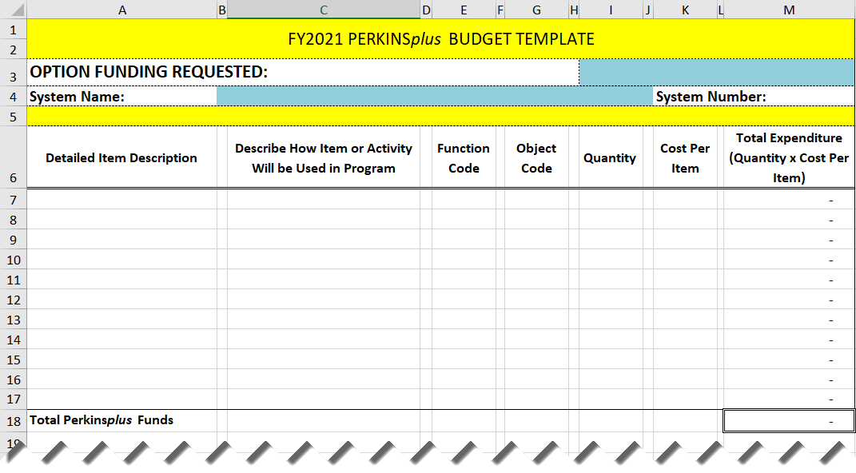

**APPENDIX “D”**

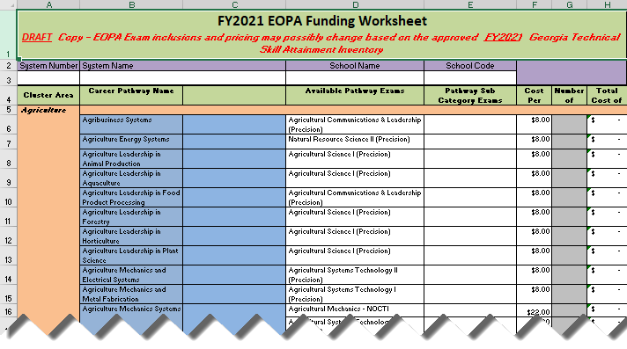

**GEORGIA DEPARTMENT OF EDUCATION**

**FY21 CTAE Perkins*plus* GRANT**

**SCORING RUBRIC FOR OPTIONS 1-6**

Using the following rubric, reviewers will assign numerical scores and prepare comments. The review team will meet to determine consensus.

|  |  |  |  |
| --- | --- | --- | --- |
|  | **Level 3**  **Meets All Criteria** | **Level 2**  **Meets Some Criteria** | **Level 1**  **Meets Few or No Criteria** |
| 1. **Activity description and the use of data to support the need for the activity.** | The proposed activity is clearly and thoroughly described, and the performance data proves the need for the activity. | There is a limited description of the proposed activity, and the performance data provides limited support for the activity. | The proposed activity is not clearly identified, and little or no performance data are included to support the need for the activity. |
| **25 Points** | **25-15** | **14-6** | **5-0** |
| **B. Plan of Operation and Timeline** | A detailed timeline, including specific steps in the implementation process is included. Persons responsible are listed. An explanation is given as to how the implementation process will be evaluated for success. | A timeline that includes some specific dates is included. Persons responsible are listed. A limited explanation is given as to how the implementation process will be evaluated for success. | The timeline does not exist or is very limited and includes few specific dates. No explanation is given as to how the implementation process will be evaluated for success. |
| **20 Points** | **20-10** | **9-1** | **0** |
| **C. Key Personnel** | Key personnel are identified by name, title, and role. | Few key personnel are identified by name, title, and role. | No key personnel are identified. |
| **5 Points** | **5-4** | **3-1** | **0** |
| **D. Budget Template** | Budget is clear, reasonable and cost effective. Budget template itemizes expenses in detail by completing all items requested on the “Budget Template.”  Budget calculations are correct. | Budget is reasonable and cost effective. Budget template identifies expenses and provides general explanation. Budget contains a few errors with some items missing from “Budget Template.” | Budget is not clear, reasonable and/or cost effective. Budget template does not provide detailed explanation of expenditures. Budget contains errors and/or is completed incorrectly. |
| **50 Points** | **50-30** | **29-15** | **14-0** |
| **System Name:** |  | **Evaluator:** | **Total Points:** |