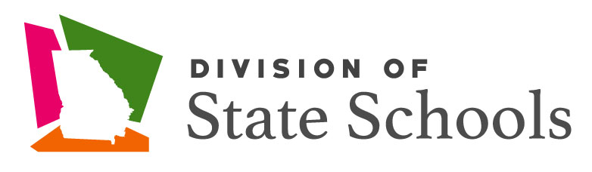

Reopening Plan
School Year: 2023-2024

Atlanta Area School for the Deaf
Georgia Academy for the Blind
Georgia School for the Deaf
(Updated 8.3.2023)

Forward

A cross-functional team of central office staff, educators, school leaders, and parents was initially organized in 2020 to address when and how to reopen the State Schools based on Community Spread Levels of COVID-19. The team addressed critical components of reopening the State Schools including: maintaining the health, wellness, and safety of the entire school community; maximizing student learning; and supporting educators and staff to adapt and respond to students’ needs. The following plan outlines expectations and protocols regarding the aforementioned critical components. Given the unfolding circumstances related to the spread of COVID-19, stakeholders need to be flexible regarding the reopening of the State Schools and the instructional delivery model (i.e., in-person learning model, remote learning model, and hybrid learning model) to be used. This plan has been updated for the 2023-24 school year based on guidance from the CDC as well as data from the Department of Public Health.

Reopening Date

Regarding a school reopening date, the State School will open in the fall in accordance with each school’s calendar shared with parents, the local education agencies and on their respective websites in the spring of 2022. Protocols are included in this plan to reopen the three schools on time while being ready to shift from in-person learning to remote learning for some or all students based on Community Spread Levels of COVID-19 as indicated by the Georgia Department of Public Health.

While we are no longer in the midst of the pandemic, the reopening of the State Schools is still guided by the health, safety, and welfare of each member of the school community, as well as their family members. The schools are ready to support varying degrees of quarantine as needed (groups of learners utilizing remote learning and/or staff working remotely). Some at-risk staff members may need modified duties but may still be able to support remote learning. All schools have return to 100% in-person instruction.
Reopening of the State Schools Focus Areas

In order for the State Schools to reopen as safely as possible and promote instruction and learning, the primary focus areas will be implemented in accordance with the reopening plan. Each focus area is discussed in this plan. Each school is expected to:

- Maintain the health, wellness, and safety of the entire school community by:
  - Ensuring compliance with the Center for Disease Control’s (CDC) and Department of Public Health’s guidance for cleaning and disinfecting schools;
  - Purchasing Personal Protection Equipment (PPE) for students and staff (as needed);
  - Promoting behaviors that reduce the spread of COVID-19;
  - Ensuring compliance with the CDC’s and Department of Public Health’s physical distancing guidance;
  - Implementing cultural responsiveness;
  - Implementing a trauma-informed approach to providing supports and interventions; and
  - Providing nutritious meals for students that are involved in an in-person, remote, or hybrid learning model
- Maximize student learning by:
  - Assessing students’ academic regression and learning loss;
  - Implementing evidenced based practices to closing the achievement gap;
  - Implementing Individualized Education Program plans;
  - Utilizing student data to inform instruction;
  - Implementing instructional differentiation;
  - Participating in the Multi-tiered System of Supports cohort; and
  - Utilizing technology to support all instructional learning models

Maintain the Health, Wellness, and Safety of the Entire School Community
- Ensure compliance with the CDC’s and Department of Public Health’s guidance for cleaning and disinfecting schools
  - In the summer of 2023, the State Schools will follow the CDC’s and Department of Public Health’s guidance regarding cleaning and disinfecting schools.
- Purchasing PPE for students and staff
  - Each school will have PPE (e.g., masks) for students and staff to use in accordance with guidance from the CDC and Department of Public Health.
  - Students and staff may use their own PPE as long as the PPE is in compliance with the guidance from the CDC and the Department of Public Health. Updated guidance now states that masks are highly encouraged but no longer mandatory.
- Promote behaviors that reduce the spread of COVID-19
  - Each school will monitor the Community Spread Level for the counties and LEAs it serves in order to be proactive in mitigating potential exposure risks before students are permitted to come on campus.
  - Staff at school are expected to educate students about behaviors that reduce the spread of COVID-19.
  - Each school will post signage around the campus that reflects information regarding how to reduce the spread of COVID-19.
  - Staff at school are expected to implement protocols for what to do if a student or staff member becomes ill at school.
  - Staff at school are expected to implement protocols for what to do if a parent informs the school that a student is ill.
  - Staff at school are expected to implement protocols for what to do if a staff member informs the school that he/she is ill.
- Ensure compliance with the CDC’s and Department of Public Health’s physical distancing guidance
  - Each school will follow the CDC’s and Department of Public Health’s guidance regarding physical distancing including but not limited to using PPE and maintaining a specified distance between individuals during any activity on campus whenever possible.

- Provide nutritious meals
  - Each school will provide students with nutritious meals that are in accordance with state and federal school nutrition requirements and regulations.
  - Each school will implement protocols for providing nutritious meals to students that are involved in an in-person learning model (when necessary)
  - Each school will implement protocols for providing nutritious meals to students that may be involved in a remote learning model (when necessary)
  - Each school will implement protocols for providing nutritious meals to students that may be involved in a hybrid learning model. (when necessary)

Maximize Student Learning
State Schools staff are committed to maximizing student learning by using the following best practices:
- Assess students’ academic regression and learning loss
- Implement evidenced based practices to closing the achievement gap
- Implement Individualized Education Program plans
- Utilize student data to inform instruction
- Implement instructional differentiation
- Participate in the Multi-tiered System of Supports cohort
- Utilize technology to support all instructional learning models

IMPORTANT: This reopening plan is a live document and will be updated as often as necessary in response data received from the CDC and the Georgia Department of Health.

