Instructions for Imputing Your Information into This Resolution:
(See corresponding number images on the screenshot below)
- At top of your screen, click on the “Review” tab.
- Then click on “Restrict Editing”.
- The sidebar will then appear to the right of your document. This feature will enable you to enter your data and remove the highlighted brackets.
- Click on “Find Next Region I Can Edit” and enter your specific information into this field.
- Once this field has your data as intended, then uncheck the box “Highlight the regions I can edit”. The brackets and highlight are now gone. You can print page 2 if desired.
- Click once again on “Restrict Editing” and the sidebar will go away. You should now have a clean document with your unique information. Save the edited document.

NOTE – If you reopen the saved document, the brackets and highlight will reappear. Follow steps 1, 2 & 5 above to make them disappear.

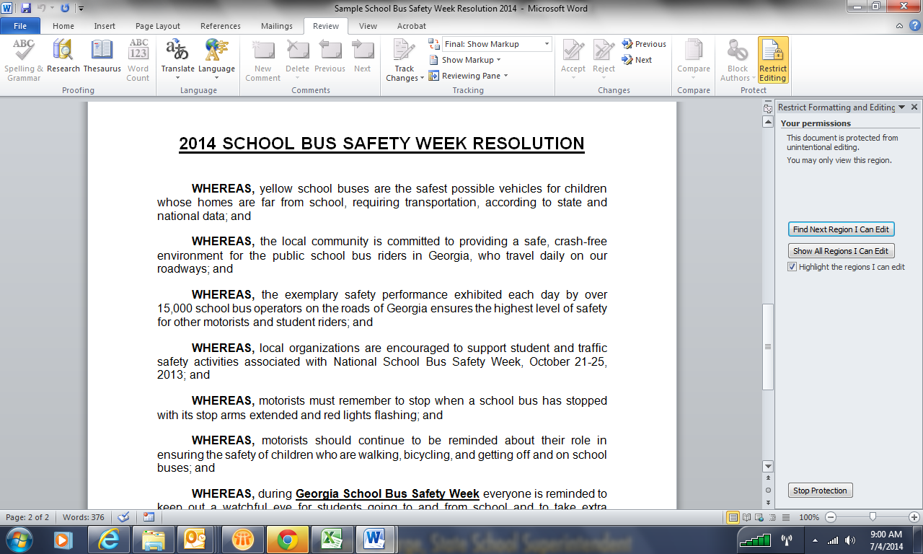
5
4
3
6
2
1

2014 SCHOOL BUS SAFETY WEEK RESOLUTION

WHEREAS, yellow school buses are the safest possible vehicles for children whose homes are far from school, requiring transportation, according to state and national data; and

WHEREAS, the local community is committed to providing a safe, crash-free environment for the public school bus riders in Georgia, who travel daily on our roadways; and

WHEREAS, the exemplary safety performance exhibited each day by over 15,000 school bus operators on the roads of Georgia ensures the highest level of safety for other motorists and student riders; and

WHEREAS, local organizations are encouraged to support student and traffic safety activities associated with National School Bus Safety Week, October 21-25, 2013; and

WHEREAS, motorists must remember to stop when a school bus has stopped with its stop arms extended and red lights flashing; and

WHEREAS, motorists should continue to be reminded about their role in ensuring the safety of children who are walking, bicycling, and getting off and on school buses; and

WHEREAS, during Georgia School Bus Safety Week everyone is reminded to keep out a watchful eye for students going to and from school and to take extra precautions around students and school buses.

NOW, THEREFORE, be it resolved, that INSERT CITY OR COUNTY NAME recognizes this year’s School Bus Safety Week’s theme of “Be Smart - Be Seen, I wait in a safe place!” during the week of October 20-24, 2014.

